**Assignment # 3**

**Programming fundamentals**

**10th November, 2020 11:59pm**

**Weightage 2.**

**Note.**

* **Please avoid plagiarism.**
* **Contact me on email in case of any query.**
* **No late submissions would be accepted.**
* **Submit assignment on google classroom and note google classroom also checks plagiarism, so be careful.**
* **Only 25 to 30% plagiarism is acceptable.**

1. **Distinct values.** Write a program Distinct.c that takes three integer command line parameters a, b, and c and prints out the number of distinct values (1, 2, or 3) among a, b, and c.
2. **What's your sign?** Write a program Zodiac.c that takes two command line integers M and D and prints the Zodiac sign corresponding to month M (1 = January, 12 = December) and day D. Use the following table.

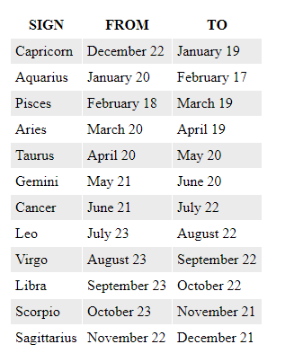

1. **Checkerboard.** Write a program Checkerboard.c that reads an integer, N from the command line, and prints out a two dimensional N-by-N checkerboard pattern with alternating spaces and asterisks, like the following 4-by-4 pattern.

|  |
| --- |
| * * * *  * * * *  * * * *  * * * * |

1. **Ordinals.** Write a program Ordinals.c that takes a command line argument N and prints out the first N ordinals, followed by Hello.

1st Hello

2nd Hello

3rd Hello

4th Hello

5th Hello

...

10th Hello

11th Hello

12th Hello

13th Hello

...

20th Hello

21st Hello

22nd Hello

***Hint*:** consider using (i % 10) and (i % 100) to determine when to use "st", "nd", "rd", or "th" for printing the ith Hello.

1. Write C program for each of the following pattern

